**Contents**

1. Windows System： 1

1.1 Installing Arduino IDE 2

1.2. Download the CH340 driver： 7

1.3. Install the driver： 7

1.4. Arduino IDE Setting 15

1.5. Start First Program 20

2. MAC System 25

2.1 Install Arduino IDE on MAC System 25

2.2 Download the CH340 driver 26

2.3.How to Install the CH340 driver 26

2.4.Setting Arduino IDE 26

3. How to add Arduino libraries 27

(1) What are Libraries ? 27

(2) How to Install a Library ? 27

1. Windows System：



**1.1 Installing Arduino IDE**

Enter the official website:<https://www.arduino.cc/>, click the **SOFTWARE** on the browse bar, and enter the **Downloads** page, as shown below;

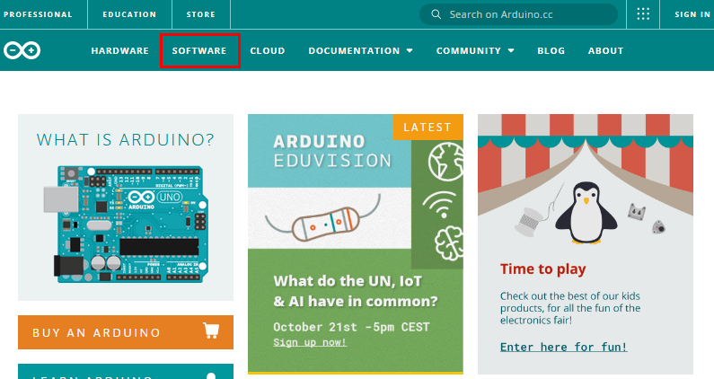

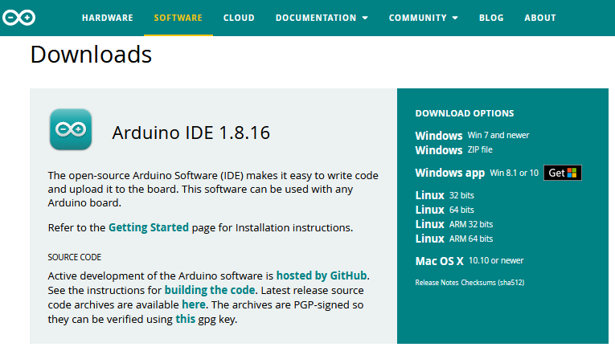

There are various versions of IDE for Arduino. Just download a version compatible with your system. Here we will show you how to download and install the windows version of Arduino IDE.

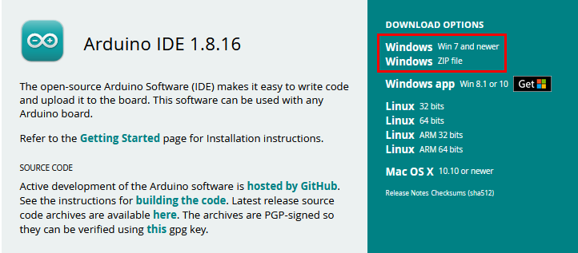

Click **Windows Win7 and newer to download the** Arduino 1.8.16 version.

Or, click **Windows ZIP file** to download the Arduino IDE directly and unzip it.



Click JUST DOWNLOAD.

After the Arduino is downloaded, click“I Agree”to continue installing

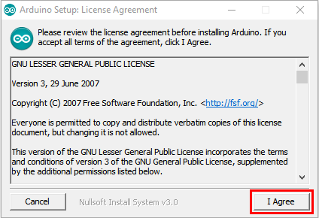

Click **Next**

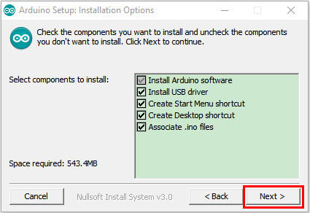

Then click **Install.**

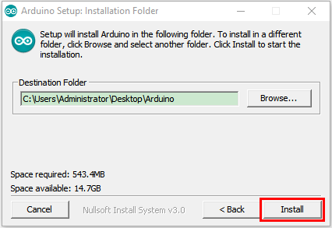

If the following page appears, click **Install.**

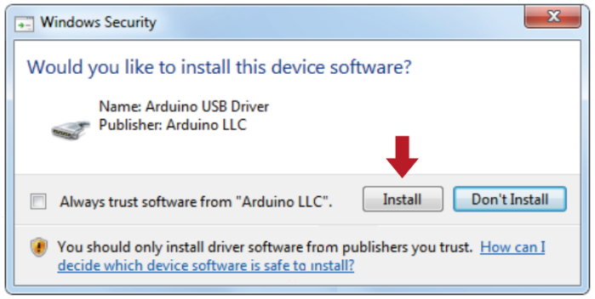

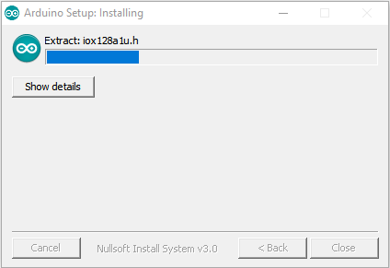

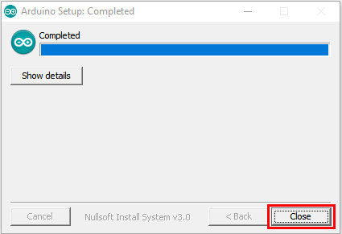

## 1.2. Download the CH340 driver：

<https://fs.keyestudio.com/CH340-WIN>

## 1.3. Install the driver：

For this part, we need to install the driver of Arduino IDE

First, let’s attach USB cable to computer. The driver can be installed automatically if the PC system is Windows 10, however, you need to install the driver manually if the PC system is other version.

The USB to serial chip of control board is CH340G, therefore, we will install its driver(usb_ch341_3.1.2009.06).

Click Computer----- Properties----- Device Manager, as shown below:

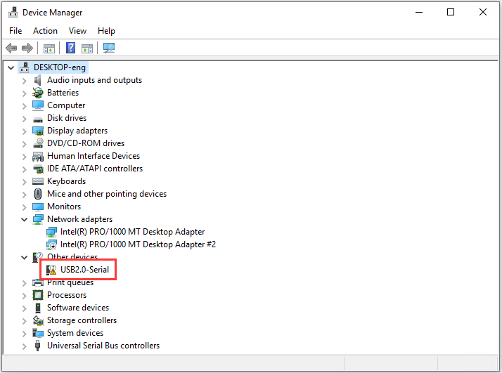

After a while, the driver USB-SERIAL CH340 will be installed. If not, right-click and select“Update Driver Program”

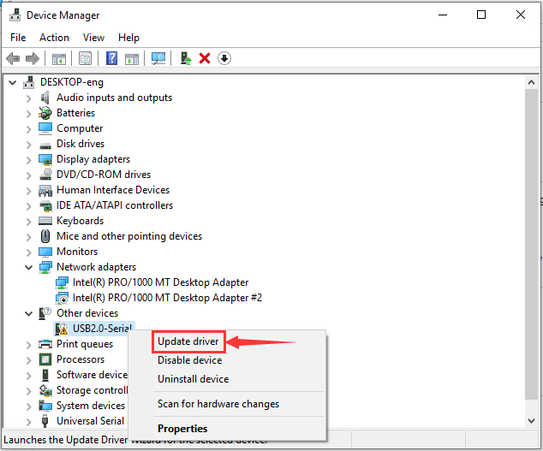

Jump into the following page and select“Browse my computer for driver software”.

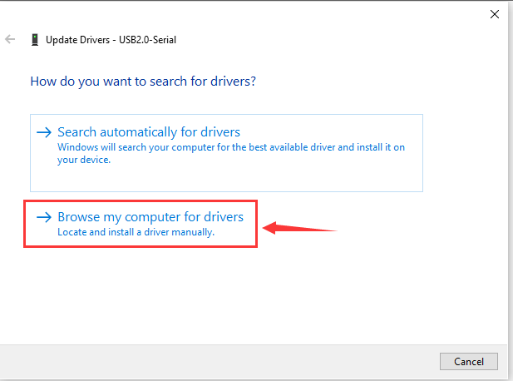

Then find and select **usb_ch341_3.1.2009.06 folder**

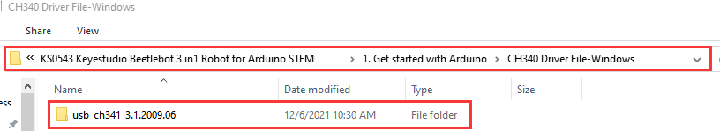

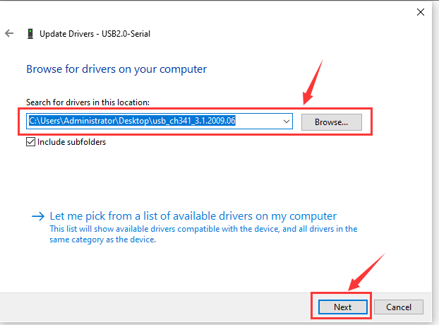

After the driver is installed, you need to click **Close.**

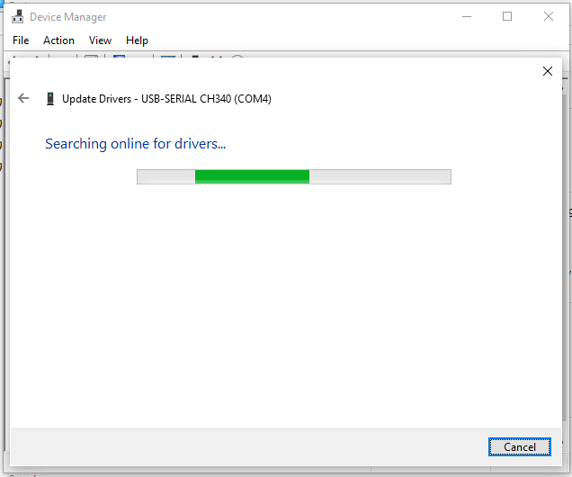

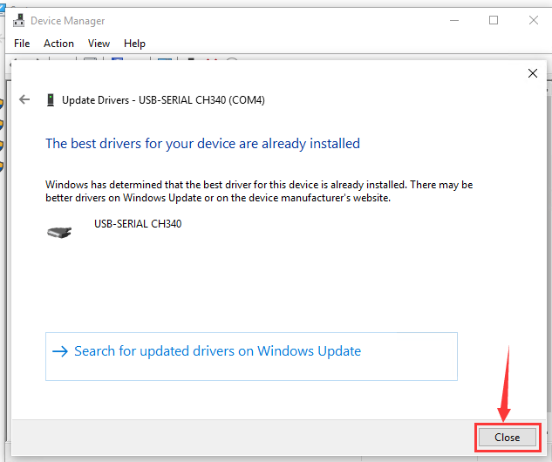

Click Computer----- Properties----- Device Manager, as shown below.

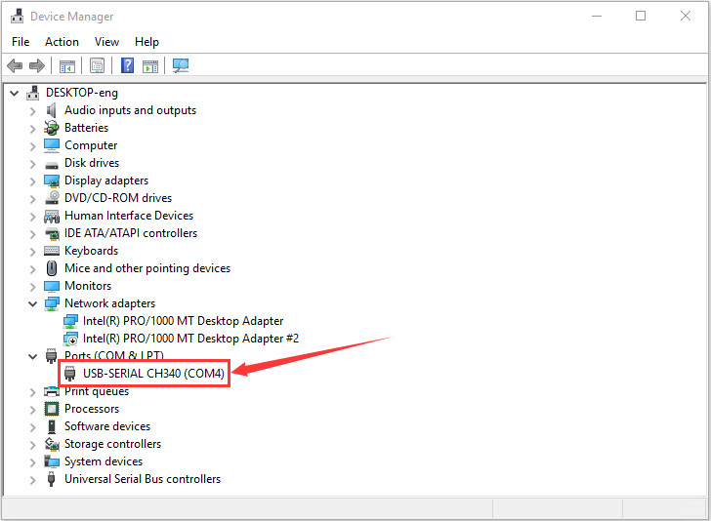

If your system is not Windows10, you need to install the driver manually.

(here, we provide the driver“usb_ch341_3.1.2009.06”)

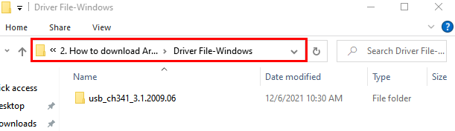

## 1.4. **Arduino IDE Setting**

Clickicon to pen Arduino IDE.

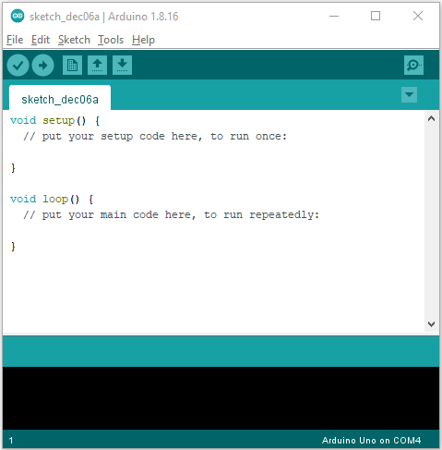

When downloading the sketch to the board, you must select the correct name of Arduino board that matches the board connected to your computer. As shown below;

(Note: we use the Arduino Nano board in this tutorial; therefore, we select **Arduino Nano)**

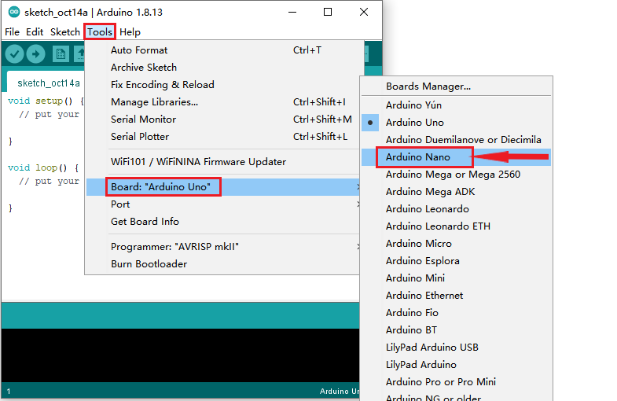

Arduino Nano board could burn new and old bootloader. New bootloader is only compatible with 1.8.9 IDE and above. Yet the old one is compatible with all versions.

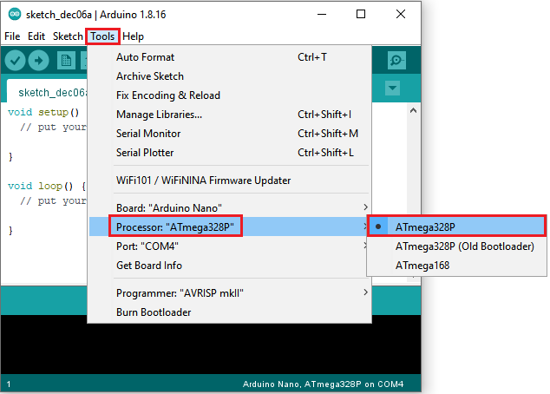

Then select the correct COM port (you can see the corresponding COM port after the driver is successfully installed).

Note: to avoid errors, the COM port should be the same as the displayed port of the device manager.



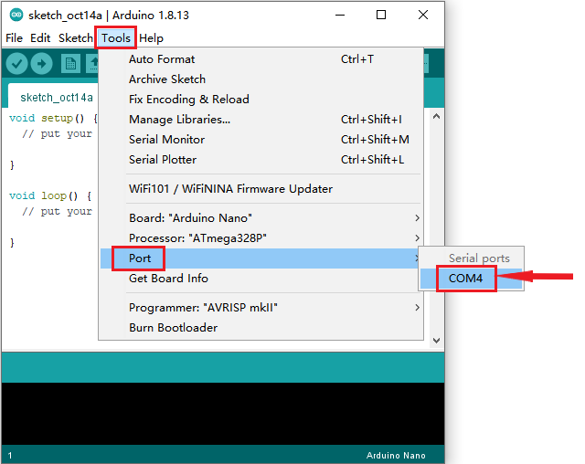

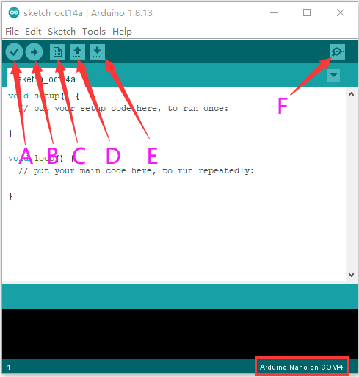

A- Used to verify whether there is any compiling mistakes or not.

B- Used to upload the sketch to your Arduino board.

C- Used to create shortcut window of a new sketch.

D- Used to directly open an example sketch.

E- Used to save the sketch.

F- Used to send the serial data received from board to the serial monitor.

**1.5.** **Start First Program**

Open the file to select **Example**, and click **BASIC**>**BLINK**, as shown below:

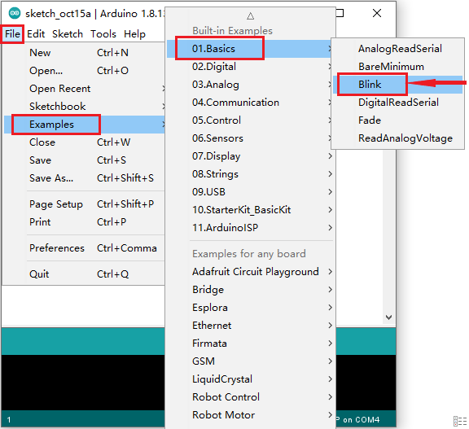

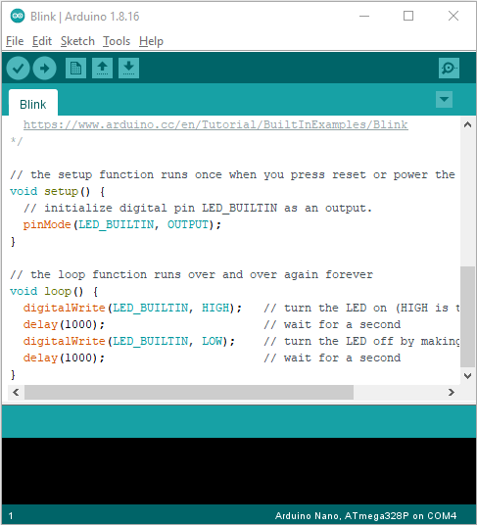

Set the correct **COM** port,and the corresponding board and COM port are shown on the lower right of IDE.

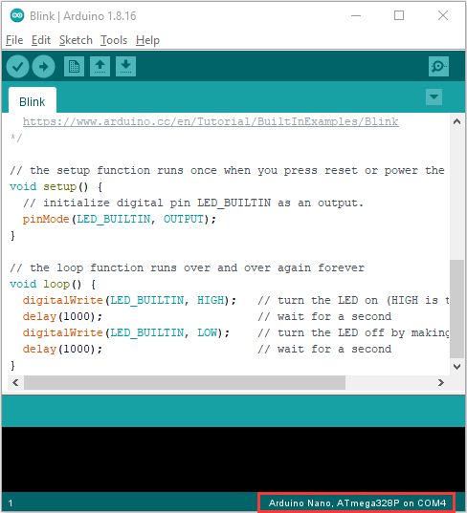

Clickto start compiling the program, and check errors.

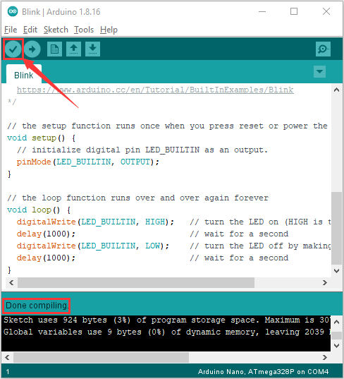

Clickto upload the program

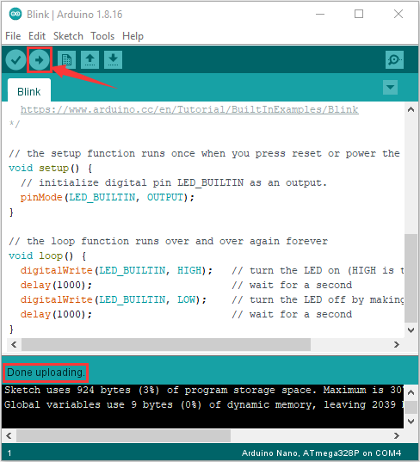

After the program is uploaded successfully, the onboard LED blinks. Congratulation, you finish the first program.

# MAC System

## 2.1 Install Arduino IDE on MAC System

The installation instruction is as same as the chapter 1.1, as shown below:

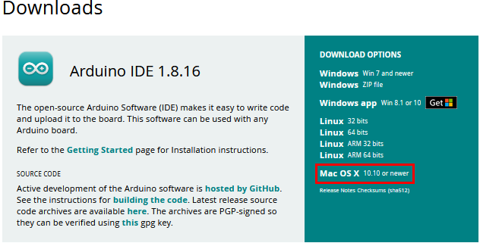

## 2.2 Download the CH340 driver

<https://fs.keyestudio.com/CH340-MAC>

## 2.3.How to Install the CH340 driver

Please refer to the following link:

<https://wiki.keyestudio.com/Download_CH340_Driver_on_MAC_System>

## 2.4.Setting Arduino IDE

The setting method is as same as the chapter 1.4 except from COM port, as shown below:

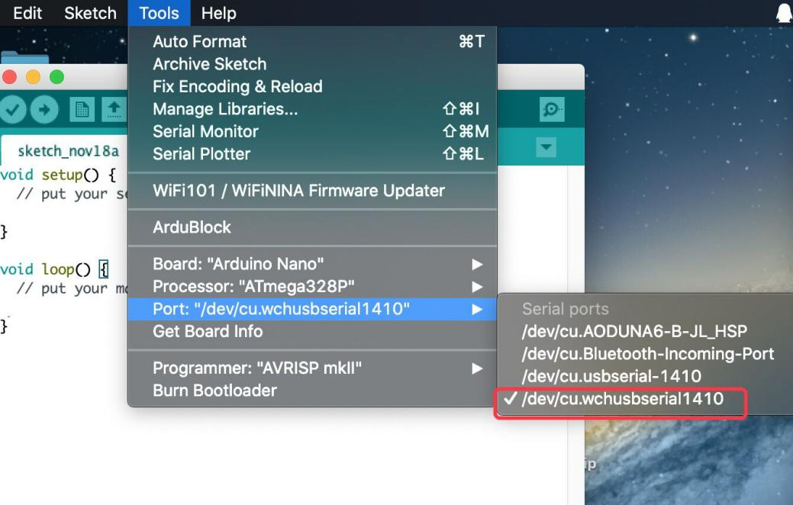

# How to add Arduino libraries

**(1) What are Libraries ?**

[Libraries](https://www.arduino.cc/en/Reference/Libraries)are a collection of code that make it easy for you to connect a sensor,display, module, etc.

For example, the built-in LiquidCrystal library helps talk to LCD displays. There are hundreds of additional libraries available on the Internet for download.

The built-in libraries and some of these additional libraries are listed in the reference. (https://www.arduino.cc/en/Reference/Libraries)

**(2) How to Install a Library ?**

Here we will introduce the most simple way to add libraries .

**Step 1:** After downloading well the Arduino IDE, you can right-click the icon of Arduino IDE.

Find the option "Open file location"

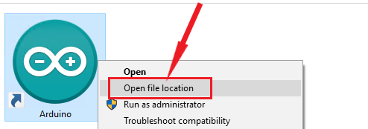

**Step 2:** Click **Open file location** >libraries

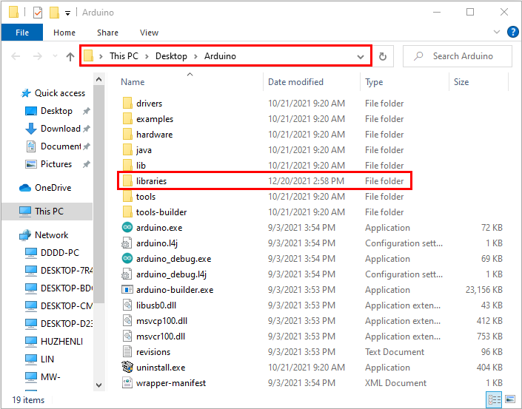

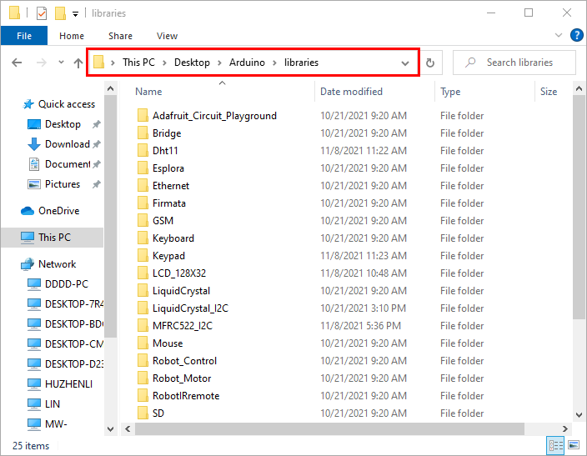

**Step 3:** Next, find out the“libraries”folder

(seen in the link: https://fs.keyestudio.com/KS0543)

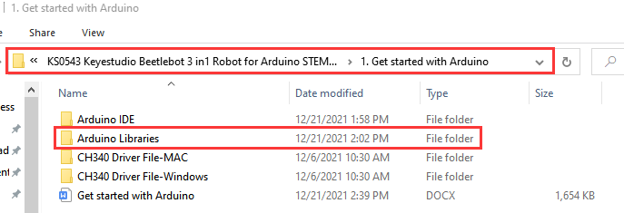

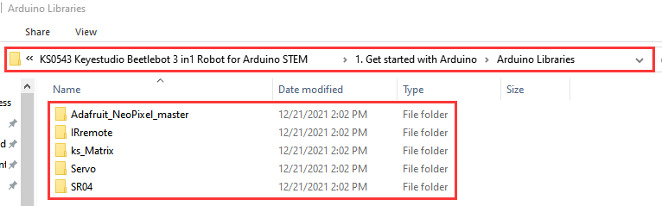

Copy 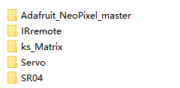in the libraries folder of Arduino.

Then click“Replace the files in the destination”

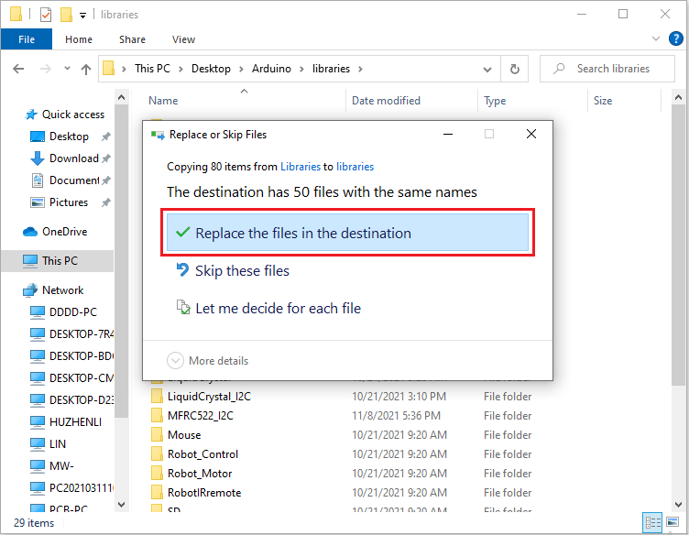

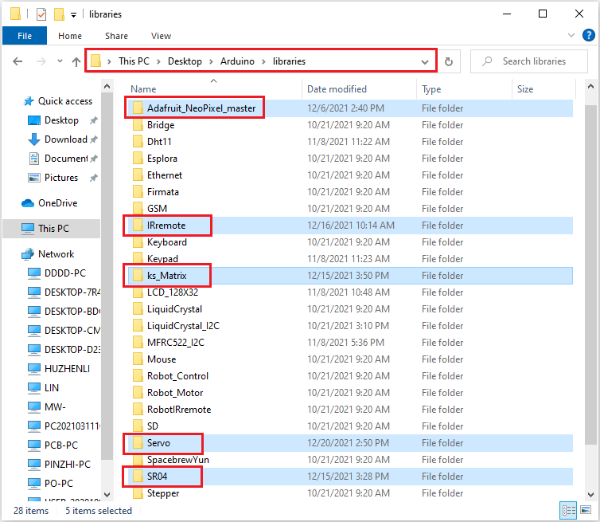

From the above picture, libraries are added successfully.